**Trigger Q1**

Create an account table(acc_no, cname, balance, branch_name), loan table(loan_no, amt,

branch_name), borrower table(cname, loan_no). Create a trigger to perform the following operations:

Whenever the balance becomes negative, create a loan in the amount of overdraft. The loan_no is given same as acc_no.

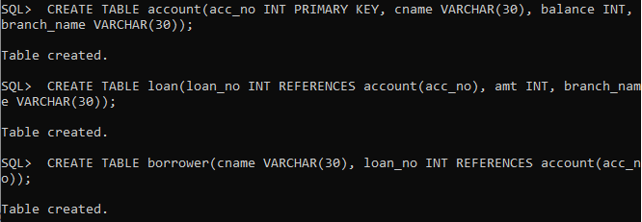

**Trigger:**

CREATE OR REPLACE TRIGGER t

AFTER UPDATE ON account

for each row

WHEN (new.balance < 0)

begin

insert into loan values(:old.acc_no,:new.balance*-1,:old.branch_name);

insert into borrower values(:old.cname,:old.acc_no);

end;

**Output:**

